

Motor power calculation for Suzuki Bolan

By

Muhammad Saad

CEO, CST EV

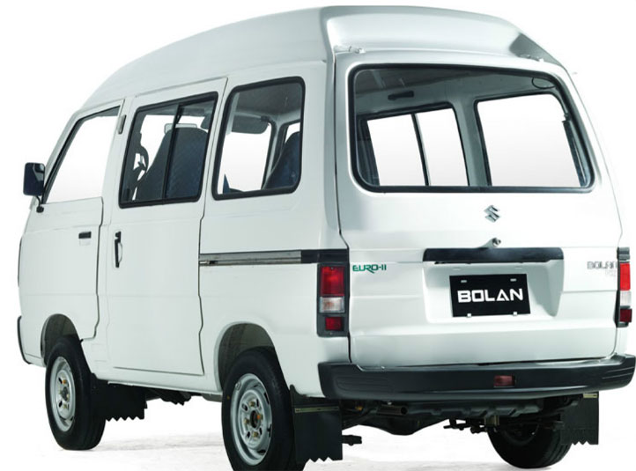

# **OVERVIEW**

# The Suzuki Bolan is also known as Carry Daba in Pakistan. Suzuki Bolan featured some very minor cosmetic upgrades and a brand new Euro-II compliant engine. Suzuki Bolan is a mid-engine front wheel drive mini MPV. Suzuki Bolan MPV has remained virtually unchanged since its launch in Pakistan in the early 90’s

# **Parameters**

# Weight of the vehicle after EV conversion

<https://www.suzukipremier.com/suzuki-bolan/>

Kerb weight = 550kg

Passenger Weight: 700 kg

Fuel tank with full fuel = 40 kg

Battery Weight = 150kg

Motor kit estimated weight = 30kg

Engine Weight = The engine weight of a Suzuki Bolan with a 769cc engine is usually around 70 kg

**Weight without engine:**

Kerb weight 550 kg - Engine Weight 70 kg - Fuel tank with full fuel 40 kg= 440 kg

Weight without engine: 440 kg

**Weight of Bolan after EV conversion:**

Weight without engine (440 kg) + battery weight (150) + Passenger Weight (700 kg) + Motor kit estimated weight (30kg) = 1,320 KG

Weight of Bolan after EV conversion: 1320 KG

# Dimensions:

<https://www.gari.pk/new-cars/suzuki/bolan/specs-features/\\>

|  |  |  |  |
| --- | --- | --- | --- |
| [Overall Height](https://www.gari.pk/glossary/overall-height/) | 1845 mm / 6'1" feet | [Overall Length](https://www.gari.pk/glossary/overall-length/) | 3255 mm / 10'9" feet |
| [Overall Width](https://www.gari.pk/glossary/overall-width/) | 1395 mm / 4'7" feet | [Wheel Base](https://www.gari.pk/glossary/wheel-base/) | 1840 mm / 6'1" feet |
| [Ground Clearance](https://www.gari.pk/glossary/ground-clearance/) | 140 mm / 0'6" feet |  |  |

# Total Power usage

**Total Power usage** = Power usage due to air drag force + Power usage due to rolling resistance + Power usage due to the inclination angle of the road

We assume Power usage due to the inclination angle of the road = 0, this will result in a speed decrease on inclined roads but it is normal and also occurs with fuel vehicles.

So the final formula is

**Total Power usage** = Power usage due to air drag force + Power usage due to rolling resistance

Now we discuss the calculation of each of the above resistance forces

# Air drag calculation

Density of the air ρ = 1.204 kg/m3  (at around 15 degrees Celsius, it increase in colder weathers)

<https://en.wikipedia.org/wiki/Density_of_air#:~:text=At%20101.325%20kPa%20(abs)%20and%2015%20%C2%B0C%20(59,62%20lb%2Fcu%20ft)>

Frontal area A estimated by a-c: A = 2.0 m2

Drag coefficient, Cd = 0.40



Drag Force = ½ (pCdAV2)

Force constant c for Bolan = ½ (pCdA) => ½ (1.204 x 0.40 x 2.0) = 0.4816

The air resistance formula can be mathematically stated as:

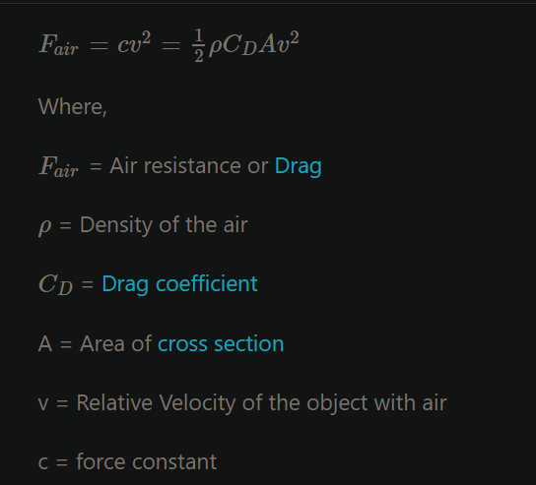

<https://testbook.com/physics-formulas/air-resistance-formula>

We have the formula and data to calculate the drag force acting on the vehicle but we use an online calculator to fill up the table below:

<https://www.omnicalculator.com/physics/drag-equation>

|  |  |  |
| --- | --- | --- |
| **Speed** | **Fair = Drag Force measure in Newtons** | **Power usage due to drag force = Fair x Velocity** |
| 40 km/h (11.11 m/s) | 59.44 N | 660.37 W |
| 60 km/h (16.67 m/s) | 133.83 N | 2,230.94 KW |
| 70 km/h (19.44 m/s) | 182 N | 3,538.08 W |
| 80 km/h (22.22 m/s) | 237.8 N | 5,283.91 KW |
| 90 km/h (25 m/s) | 301 N | 7,525 KW |
| 100 km/h (27.78 m/s) | 371.7 N | 10,325.82 KW |
| 120 km/h (33.33 m/s) | 535 N | 17,831.55 KW |

## Example of drag force calculation at 60 km/h (16.67 m/s) using the online calculator

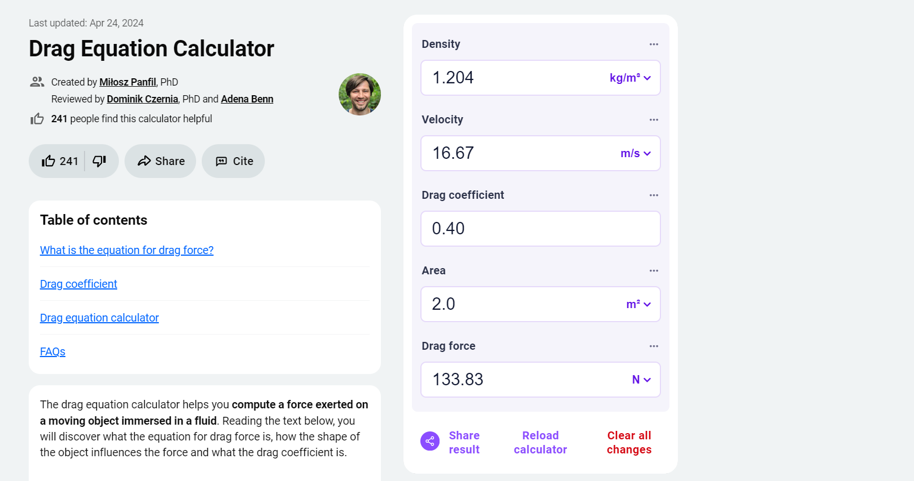

**Power usage due to drag force** = Drag force x the velocity of the vehicle = ½ (pCAV2) x V = ½ pCAV3

For example, the Power usage due to drag force at 60 km/h (16.67 m/s) = 0.5 x 1.204 x 0.40 x 2.0x 16.673 = 2,230.94 Watts

Please note that the power usage due to the drag force acting on the vehicle increases as cube of the current velocity/speed so the higher the speed the higher the power usage. The power usage increases exponentially with speed so therefore we limit the EV top speed to 120 km/h.

# Rolling Resistance

This is the resistance to the motion of the car's tires as they roll on the road. It's influenced by factors like weight of the vehicle, tire type, road surface, and tire pressure.

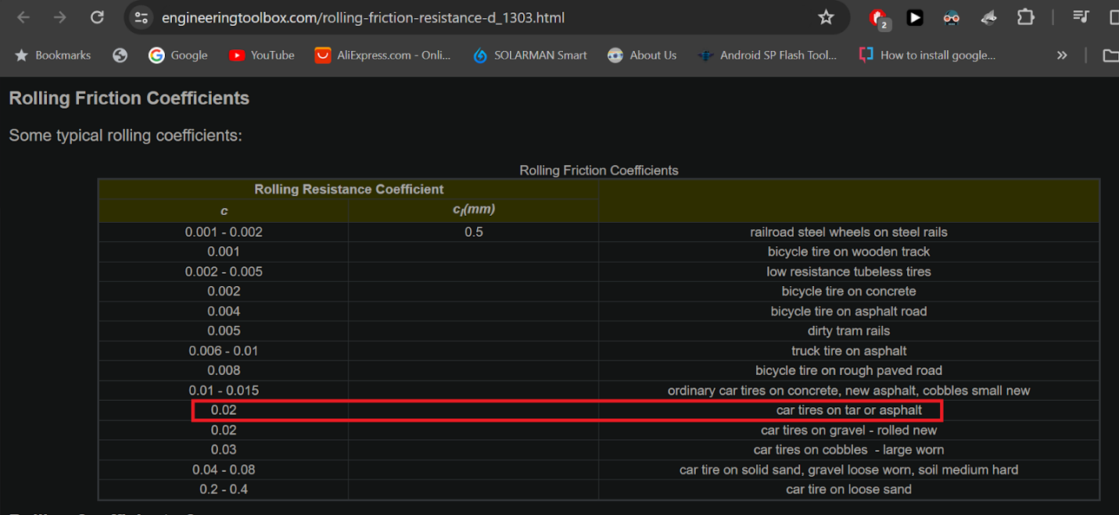

Table taken from <https://www.engineeringtoolbox.com/rolling-friction-resistance-d_1303.html>

Here is an online calculator for calculating the rolling resistance force

<https://www.omnicalculator.com/physics/rolling-resistance#rolling-resistance-basics>

Weight of Bolan after EV conversion = 765 kg

Rolling resistance = 150.1 N

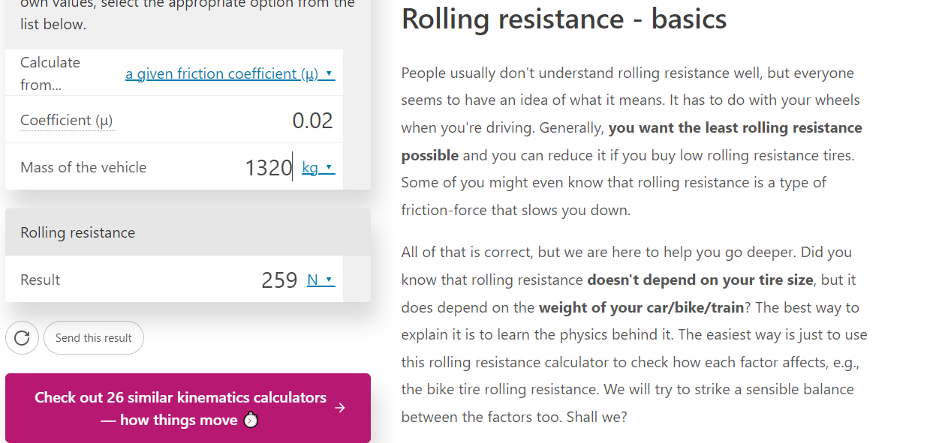

|  |  |  |
| --- | --- | --- |
| **Speed** | **Rolling Resistance Force** | **Power usage due to rolling resistance = RR x Velocity** |
| 40 km/h (11.11 m/s) | 259 N | 2,877.49 W |
| 60 km/h (16.67 m/s) | 259 N | 4,317.53 W |
| 70 km/h (19.44 m/s) | 259 N | 5,034.96 W |
| 80 km/h (22.22 m/s) | 259 N | 5,754.98 W |
| 90 km/h (25 m/s) | 259 N | 6475 W |
| 100 km/h (27.78 m/s) | 259 N | 7,195.02 W |
| 120 km/h (33.33 m/s) | 259 N | 8,632.47 W |

# Suzuki Bolan calculation for motor power vs speed

|  |  |  |  |  |  |
| --- | --- | --- | --- | --- | --- |
| **Speed** | **Drag Force** | **Power usage** | **Rolling Resistance Force** | **Power usage** | **Total Power usage** |
| 40 km/h (11.11 m/s) | 59.44 N | 660.37 W | 259 N | 2,877.49 W | 3,537.86 W |
| 60 km/h (16.67 m/s) | 133.83 N | 2,230.94 W | 259 N | 4,317.53 W | 6,548.47 W |
| 70 km/h (19.44 m/s) | 182 N | 3,538.08 W | 259 N | 5,034.96 W | 8,573.04 W |
| 80 km/h (22.22 m/s) | 237.8 N | 5,283.91 W | 259 N | 5,754.98 W | 11,038.89 W |
| 90 km/h (25 m/s) | 301 N | 7,525 W | 259 N | 6475 W | 14,000 W |
| 100 km/h (27.78 m/s) | 371.7 N | 10,325.82 W | 259 N | 7,195.02 W | 17,520.84 W |
| 120 km/h (33.33 m/s) | 535 N | 17,831.55 W | 259 N | 8,632.47 W | 26,464.02 W |

There are 20-25% losses in transmission, clutch disk, ball bearings, motor inefficiency etc. so we adjust the motor power to be 20% higher than the power usage.

|  |  |  |  |  |
| --- | --- | --- | --- | --- |
| **Speed** | **Total Power usage** | **Motor power needed = 20% higher than power usage** | **Energy usage per km** | **Mileage per charge on a 21.5 kWh battery** |
| 40 km/h (11.11 m/s) | 3,537.86 W | 4,245.43 W | 106.13 Wh/km | 202 km |
| 60 km/h (16.67 m/s) | 6,548.47 W | 7,858.16 W | 130.96 Wh/km | 164 km |
| 70 km/h (19.44 m/s) | 8,573.04 W | 10,287.64 W | 146.96 Wh/km | 146 km |
| 80 km/h (22.22 m/s) | 11,038.89 W | 13,246.66 kW | 165.58 Wh/km | 129 km |
| 90 km/h (25 m/s) | 14,000 W | 16,800 kW | 186.66 Wh/km | 115 km |
| 100 km/h (27.78 m/s) | 17,520.84 W | 21,025.008 kW | 210.25 Wh/km | 102 km |
| 120 km/h (33.33 m/s) | 26,464.02 W | 31,756.82 kW | 264.64 Wh/km | 81 km |

The higher the speed, the higher the power usage and thus lower the range.

# Conclusion

A PMSM motor rated for 10kW should be enough to run the Suzuki Bolan at 70 km/h for 197 km with a 72 kWh battery. The peak power of such motors is usually double the rated power but we will consider the rated power because the motor if run at peak power continuously can get damaged.

# Power consumption and hence motor power requirement increases with speed

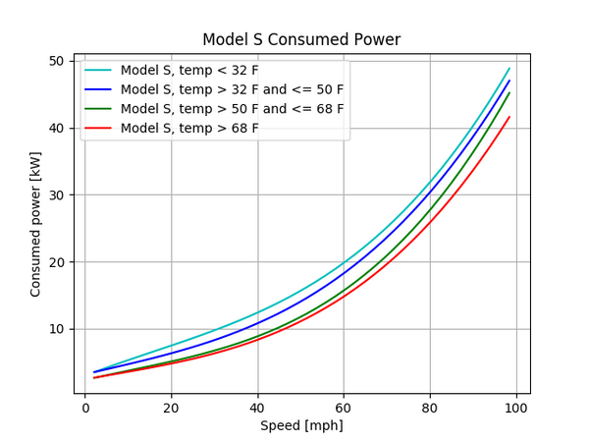

# The range decreases at higher speeds

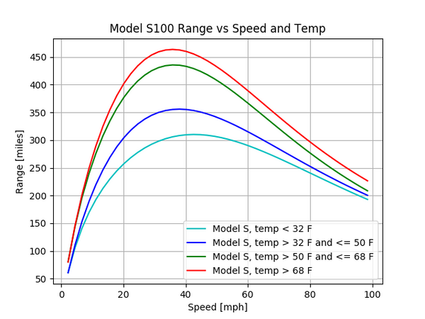

Graphs taken from <https://cleantechnica.com/2018/07/15/tesla-range-plotted-relative-to-speed-temperature-graphs/>